|  |  |  |
| --- | --- | --- |
|  | **Mizān – A Workload Management Web App**  **Phase 2** | |
| **Group Id:** | | Group 4, Ahya-Bsmalla-Carla-Ganna |
| **Group Members:** | | **Emails:**  [**ah2204901@student.qu.edu.qa**](mailto:ah2204901@student.qu.edu.qa)  [**bm2204404@qu.edu.qa**](mailto:bm2204404@qu.edu.qa)  [cc2206774@student.qu.edu.qa](mailto:cc2206774@student.qu.edu.qa)  [gs2205763@student.qu.edu.qa](mailto:gs2205763@student.qu.edu.qa) |

# Grading Rubric - In the Functionality column please specify either:

***Working (completed x%)*, *Not Working (completed x%)* or *Not done*.**

|  |  |  |  |  |
| --- | --- | --- | --- | --- |
| Criteria | | % | Functionality* | Quality of the implementation |
| 1. Entity-Relation (ER) Diagram | | 8% | 100% |  |
| 1. Seed Database | | 10% | 100% |  |
| **2) DB Repositories implementation** | | **76%** | 100% |  |
|  | **Login** | 5 | 100% |  |
|  | **Image result for add task icon Add Assessment** | 10 | 100% |  |
| **https://cdn1.iconfinder.com/data/icons/MetroStation-PNG/128/MB__tasks.png Update Assessment** | 6 | 100% |  |
| **Image result for delete task icon Delete Assessment** | 6 | 100% |  |
| **Related image Get Assessments** | 15 | 100% |  |
| **Related image Add Course Comment (including reply to a comment)** | 14 | 100% |  |
| **Related imageGet Course Comments** | 8 | 100% |  |
| Image result for Report icon**Courses Workload Summary Report** | 12 | 100% |  |
| **3) Testing documentation** using screen shots illustrating the app testing.  - Discussion of the project contribution of each team member [-10pts if not done] | | 6% | 100% |  |
| **Total** | | 100 |  |  |
| Copying and/or plagiarism or not being able to explain or answer questions about the implementation | | -  100 |  |  |

# ER Diagram and Prisma Studio

# Models and Class

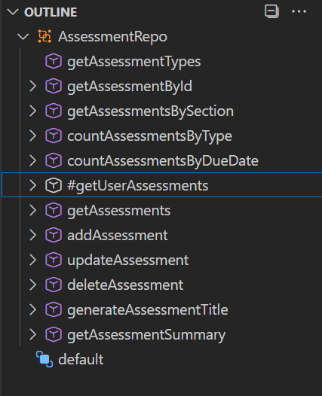

Assessments.js

Auth.js

Comments.js

Sections.js

Semester.js

Utils.js

Seed.js

## Login

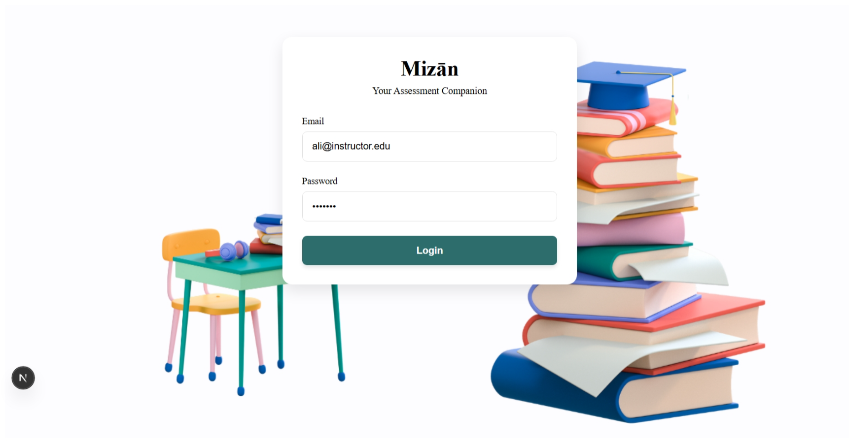

## Add Assessment



## Update Assessment



## Delete Assessment

## Get Assessments

## Add Course Comment (including reply to a comment)



## Get Course Comments

## Courses Workload Summary Report

1. **Summary of team member contributions**

|  |  |
| --- | --- |
| **Completed tasks** | **Member(s)** |
| * Prisma Schema | Ganna Soltan  Ahya AlWattar  Bsmalla Mostafa  Carmela Chavez |
| * Seed Database | Ganna Soltan  Ahya AlWattar  Bsmalla Mostafa  Carmela Chavez |
| * DB Repositories | Ganna Soltan  Ahya AlWattar  Bsmalla Mostafa  Carmela Chavez |
| * Documentation | Ganna Soltan  Ahya AlWattar  Bsmalla Mostafa  Carmela Chavez |